DMER Intake Automation

The Driver Medical Review intake process is experiencing a sustained backlog of Driver Medical Examination Reports (DMER) within the Mercury DPS General and Unknown Queues.
The Intake process (triage) handled in the Client Services (Intake) team is manual, inconsistent and cumbersome involving multiple systems (DPS/Kofax, Mercury, ICBC Drivers System/MXM). Most of the documents in the Mercury system are dependent on the CS team’s interpretation to ensure the characters/fields in the files are visible and legible for interpretation to proceed to next step in the intake process.

What is DMER?
RoadSafetyBC uses the Driver’s Medical Examination Report (DMER) to make driver medical fitness decisions.
The report provides us with the information we need to assess if a person is medically fit to drive. We use it to understand if a person’s medical condition affects their driving.

DMER Optimization and Intake Enhancement - Architecture (Azure Cloud)

This solution introduces an AI-enabled pipeline that retrieves DMER documents from the Mercury (Dynamics) system and performs automated document extraction, normalization, and rule-based evaluation to support faster and more consistent medical review. The architecture provides scalable processing, centralized auditability, and a review dashboard for operational visibility while preserving Mercury as the system of record for original documents and case management.

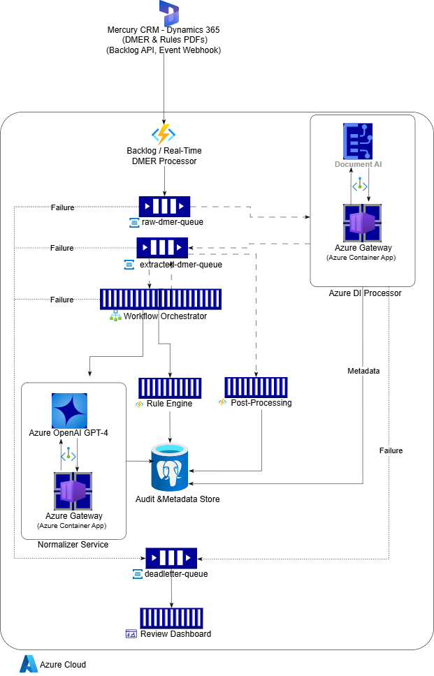

Architecture Overview
The solution is deployed fully within Microsoft Azure and uses managed services to reduce operational overhead.
Core Azure services utilized:
- Azure Functions
- Azure Container Apps
- Azure Service Bus
- Azure PostgreSQL Flexible Server
- Azure Blob Storage
- Azure Document Intelligence.
- Azure OpenAI Service
- Azure Monitor
All AI services are accessed via private endpoints within a secured Virtual Network (VNet). Managed Identities are used for secure, passwordless authentication across services.

Components in detail
- Mercury System: The DMER documents originate from the Mercury system via:
  - Backlog(DPS General & Unknown Queue) batch processing: An API retrieves batch DMERs along with metadata and a DMER pre-signed URL, or directly reads from S3 and uses a Mercury GET API to fetch the DMER metadata.
  - Real-time/New DMER event trigger: An event-based trigger for newly submitted DMERs.
- Backlog/Real Time DMER processor: An Azure Function acts as the intake processor with a Batch Poller(Timer trigger) and an Event Webhook Listener(HTTP trigger). It publishes messages to the raw-dmer-queue.
- Raw-dmer-queue: The system uses Azure Service Bus for asynchronous communication. This queue contains new DMER documents ready for OCR processing. Any issues with a raw DMER are routed to the dead-letter queue.
- Azure DI Processor: An Azure Container App subscribes to the raw-dmer-queue and downloads the DMER from S3 or a provided URL. It invokes Azure Document Intelligence via a private endpoint to perform OCR, computes the document hash, and saves the metadata and hash in the PostgreSQL database. The results are published to the extracted-dmer queue. Failures are automatically routed to the dead-letter queue.
- Extracted-dmer-queue: This queue contains OCR-processed DMER documents.
- Workflow orchestrator: A durable workflow orchestrator implemented using Azure Functions coordinates the following:
  - Metadata loading
  - Duplicate validation
  - Case creation or update
  - Normalization invocation
  - Mercury system updates
  - Completion marking
  - Failure routing
- Normalizer Service: The Normalizer Service is deployed as an Azure Container App integrated with Azure OpenAI Service. This component transforms free-text medical details into deterministic, rule-ready structured data. It performs:
  - Section-Based Extraction based on strict schema per section
  - Evidence validation by comparing extracted text with the original source text
  - Storage of structured ontology data in the PostgreSQL database
- Rule Engine: The rule engine is implemented using Go Rules/Zen within an Azure Function. It applies the rules and determines the next action and corresponding reason. The rules.json file used for evaluation is stored in Azure Blob Storage.
- Post Processing: An Azure Function performs auditing. Audit metadata is stored in PostgreSQL. Centralized logging and monitoring are implemented using Azure Monitor and Application Insights.
- Audit & Metadata Store:PostgreSQL is used to store DMER metadata, document hash, processing timestamps, rule version, decision outcomes, and error logs.
- Deadletter-queue: Azure Service Bus is used to capture all failed DMERs.
- Review Dashboard: A dashboard is used to monitor successful and failed cases. This can be implemented using Microsoft Power BI. This can be implemented in the mercury system.

Hybrid Approach: For the hybrid deployment model, the Azure DI Processor and Normalizer Service remain in Azure Cloud, while all other components are hosted in OpenShift. Communication between OpenShift and Azure is established using Azure ExpressRoute.

